Call for Proposals
International Symposium: Archaeology of Yuan Dadu and the Steppe Capitals
Institute of Archaeology, Beijing Union University
10-11th December 2022, Beijing, China
Hybrid (Zoom & In Person)
In order to promote domestic and international exchange and cooperation in archaeology and to share the latest academic achievements in the study of Yuan Dadu and the Steppe capitals, the Institute of Archaeology and the Department of History and Museology of Beijing Union University will be organizing and hosting an International Symposium: Archaeology of Yuan Dadu and the Steppe Capitals, which will be held as a hybrid online-offline event in Beijing on 10-11th December 2022. We would like to invite the leading scholars to share their latest findings and new research in the field. This symposium will provide participants with opportunities for in-depth exchange on multiple topics and in multiple formats. The working languages of the conference will be English and Chinese, we welcome interested scholars to attend the symposium and to submit a paper in either Chinese or English should they wish to. Please find the information with regards to the venue and dates below.
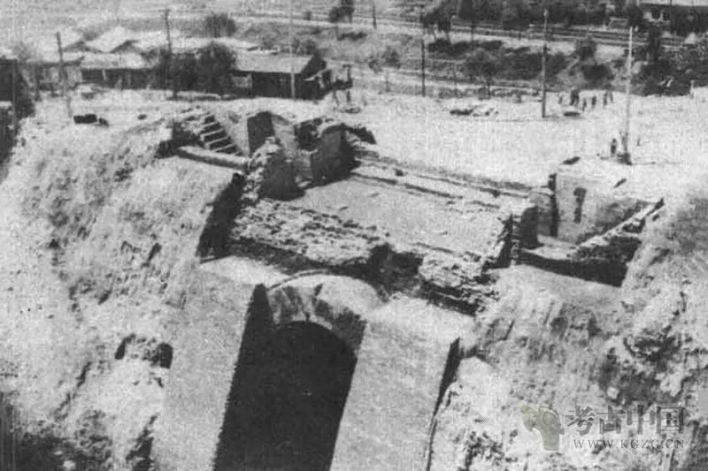
I. Conference time: December 10-11, 2022
II. Conference Venue
Offline: College of Applied Arts and Sciences, Beijing Union University
Beitucheng West Road 197, Haidian District, Beijing, China
Online：Zoom/Teams
III. The topics of the conference include:
1. Urban Archaeology of the steppe
2. Material Culture studies of the steppe
3. Urban Archaeology of Beijing from Liao to Qing dynasties
4. Stone inscriptions, documents and social culture of Yuan, Ming and Qing dynasties
IV. Schedule
December 10 (Saturday) 2022
December 11 (Sunday) 2022
V. Participating papers
For administrative purposes we request that each participant send an electronic version of their paper or an abstract (150-200 words) to hao.chunyang@hotmail.com by November 25th 2022.
VI. Contacts
Hao Chunyang 0086-18252021365 hao.chunyang@hotmail.com
Bao Yongchao 0086-18669361146 yongchaobao@qq.com

Department of History and Museology, Beijing Union University
Institute of Archaeology, Beijing Union University
October 12, 2022

